**CCT College Dublin Continuous Assessment**

| **Programme Title:** | Higher Diploma in Data Analytics for Business / Higher Diploma in AI Apps | | |
| --- | --- | --- | --- |
| **Delivery Mode:** | Online | | |
| **Cohort Details:** | Higher Diploma Data Analytics Sep2024 PT Semester 1  Higher Diploma AI Sep2024 PT Semester 1 | | |
| **Module Title(s)**: | Strategic Thinking | | |
| **Assignment Type:** | Individual | **Weighting(s):** | 20 % |
| **Assignment Title:** | CA 1 – Capstone Project Proposal | | |
| **Lecturer(s)**: | James Garza ([james@cct.ie](mailto:james@cct.ie)) | | |
| **Issue Date:** |  | | |
| **Submission Deadline Date:** | Sunday, 27th October 2024 23:59 | | |
| **Late Submission Penalty:** | Late submissions will be accepted up to **5** calendar days after the deadline. All late submissions are subject to a penalty of **10%** of the mark awarded.  Submissions received more than 5 calendar days after the deadline above **will not** be accepted and a mark of 0% will be awarded. | | |
| **Method of Submission:** | **This assignment is submitted via Moodle.** | | |
| **Instructions for Submission:** | Your work must be uploaded to Moodle.  • Capstone Project Proposal in Word format ONLY. The word count is 1,000.  • Ethics form signed by all students and submitted as PDF.  • ZIP or RAR files will not be accepted. Files must be submitted separately. | | |
| **Feedback Method:** | **Results posted in Moodle gradebook** | | |
| **Feedback Date:** |  | | |

**Student name: Yuri Braga**

**Student number: sba24328**

**Github repository : https://github.com/bragayuri/strategic-thinking-ca-1**

**Vehicle life cycle cost prediction tool**

**Introduction**

According to the union of concerned scientists *(Reichmuth, Dunn and Anair, 2022)*, consumers are more aware about the benefits of electric vehicles, such as reduced greenhouse gas emissions and improved air quality *(UCS,2020)*. However, they may find it hard to balance environmental benefits against financial considerations as a lack of tools that help to provide visibility of total cost of ownership (TCO) analysis.

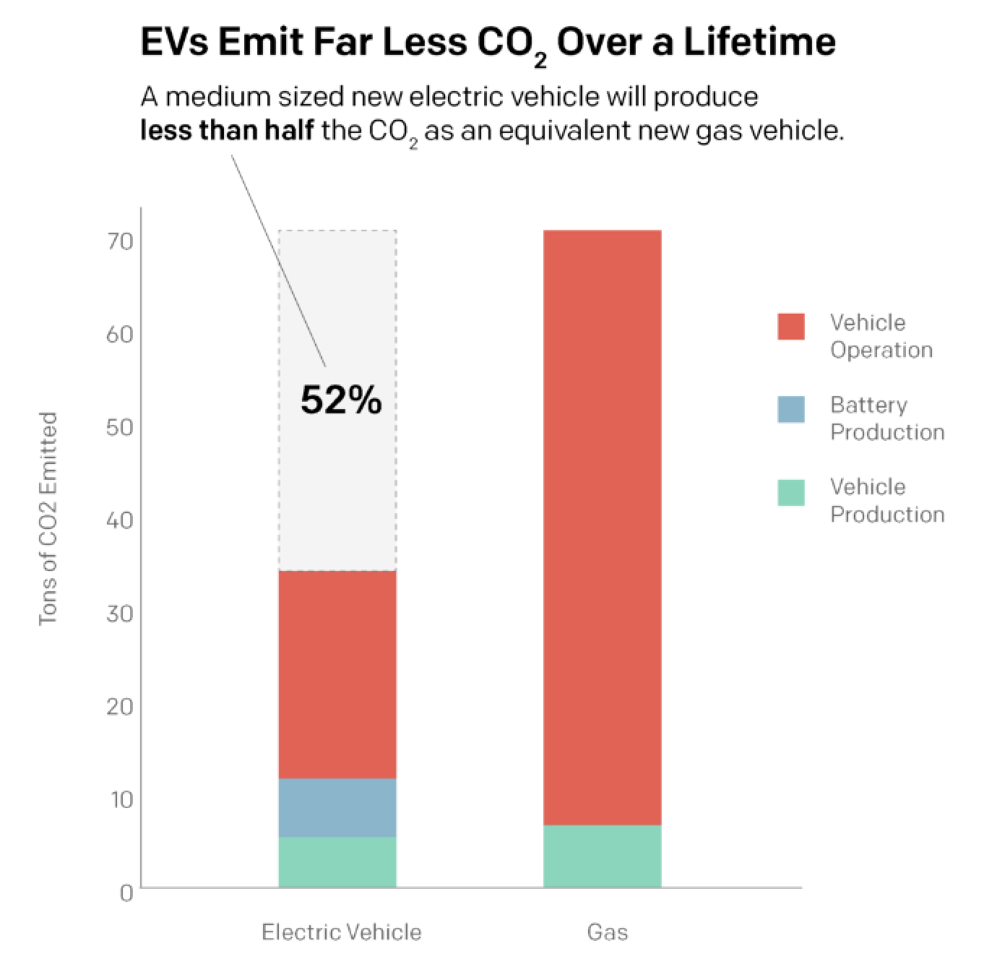

Source: [Union of Concerned Scientists](https://www.ucsusa.org/resources/driving-cleaner#read-online-content). (Casey Chin / Earthjustice)

Some key factors like insurance costs, depreciation value, maintenance, fuel consumption and others, have a direct influence in determining the total cost of ownership(TCO) over time.

While some tools like The Edmunds Inc. True Cost to Own® (TCO®) pricing system calculates the additional costs users might not consider when buying a vehicle *(Edmunds, n.d.)*, this research could not find that feature as a web service that can be easily integrated with online marketplaces and in addition to this limitation, the calculator does not promote the usage of electric vehicles to combat climate change.

Similarly, other tools like a repair cost calculator offered by AAA *(www.aaa.com, n.d.)* provide visibility over maintenance costs but it limits the user with a feature that can be incorporated with this capstone project.

This lack of an accessible, easy to integrate and easy to understand TCO analysis that encourages EV adoption, presents a clear barrier for end users looking to make informed financial and environmental decisions.

This project aims to deliver a web-based vehicle life cost prediction tool to provide predicted TCO results, promote EVs by displaying fuel types comparison , assist end users with financial decisions and promote business value.

**Problem Definition**

When buying a vehicle, consumers might encounter difficulties to predict the long-term costs associated with vehicle ownership. The following questions become difficult to answer:

**Which fuel type to choose:**

Considering fuel costs, would it be better to buy an electric or petrol?

**New vehicles vs Second-hand:**

Should I buy a new vehicle or a second hand one ?

**Long-term costs:**

How much would it cost me in the long term to choose a petrol over an electric?

**Additional Investments:**

How much would it cost to invest in an electric home plug in addition to buying an electric vehicle?

While researching online, it was identified the lack of one prediction tool that could help to solve all the above questions at once integrated with a marketplace while buying a vehicle online.

**Objectives**

1 - Deliver a web tool that can be easily accessed by any end user using a browser, that calculates and predicts the TCO (total cost of ownership), providing a solid dashboard and helping customers with the long-term financial responsibility of their decisions.

2 - Provide a personalised TCO report, empowering the end user with valuable information, collaborating with more informed decisions.

3 - Encourage the adoption of EV vehicles by displaying the long-term benefits but without biasing information.

4 - Increase business value by promoting the tool, increasing online marketplace engagement and lead conversion.

**Impact**

**Buyers:**

Without the proper visualization of TCO, buyers would make uninformed decisions, which leads towards higher expenses over time and consequently dissatisfaction with their purchase.

**Environmental Goals:**

While not certain about the benefits and costs of EVs, users would take longer to consider its adoption. This directly impacts on the world goal to reduce carbon emissions and combat climate change.

**Sales:**

Business lacks chances to engage customers with a valuable decision tool that can lead to more sales conversions and user satisfaction.

**Project Scope**

**Included in the Project**

* **Data collection and analysis**

Vehicle purchase prices, insurance rate, depreciation rate, repair and maintenance costs, fuel type costs, infrastructure for electric vehicles, government incentives and tax implications, financing incentives on green vehicles.

* **Predictive Models**

Project would develop machine learning models to help forecast the following:

Depreciation metrics, maintenance costs, fuel consumption costs, insurance costs over time.

By using algorithms such as linear regression, time-series forecasting and decision trees.

* **Web Interface**

Web-component that can be easily integrated on dealership websites

Usage of modern web technologies to build a scalable SDK that can expose the web-component.

**Excluded from the Project**

* **Mobile Application Development**
* **Automated QA coverage**

**Methodology**

* **Project Management**: Agile methodologies with sprint cycles of 2 weeks.
* **Data collection:** Collect data on the topics described above.
* **Model development**: Data processing, algorithm selection, training and validation.
* **Web development**: Develop the interface in VueJs and Javascript. Create a web-component SDK.
* **Backend**: Implement server to connect with the LLM service and provide the api to the front-end SDK.

**Required Data Sources**

Ideally to deliver the above functionality, at least 9 vehicle related data sources are required to achieve the full tool capability.

List of required data source, possible sources, usage permission:

**1 - Vehicle Pricing:**

SIMI

Accessible in here:

<https://www.simi.ie/en/motorstats/recommended-price-guide>

ECB

Accessible in here:

https://data.ecb.europa.eu/data/concepts/second-hand-vehicles?tags_array%5B0%5D=Second-hand%20vehicles&filterSequence=tags_array

**2 - Depreciation**

Kaggle

Accessible in here:

<https://www.kaggle.com/code/alexandersylvester/used-cars-eda-with-depreciation-analysis>

https://www.kaggle.com/datasets/taeefnajib/used-car-price-prediction-dataset

**3 - Maintenance**

AAA

Accessible in here:

<https://www.bankrate.com/loans/auto-loans/average-car-maintenance-costs/>

https://www.theaa.ie/motoring-advice/cost-of-motoring/

**4 - Insurance**

Chill

Accessible in here:

<https://www.chill.ie/blog/car-insurance-pricing-index/>

**5 - Financing**

Accessible in here: :Statista (<https://www.statista.com/statistics/290673/auto-loan-rates-usa/>)

Investopedia

https://www.investopedia.com/articles/personal-finance/061615/how-interest-rates-work-car-loans.asp

**6 - Fuel type cost**

Accessible in here: : https://www.gulfoilltd.com/exploring-ev-and-petrol-running-costs-across-nations

**7 - EV national Infrastructure**

Accessible in here: : https://www.electromaps.com/en/charging-stations/ireland/county-dublin/dublin

**8 - Government Grants and Tax**

Citizen Information

Accessible in here: (https://www.citizensinformation.ie)

Revenue

Accessible in here:

<https://www.revenue.ie/en/vrt/calculating-vrt/electric-hybrid-vehicles.aspx>

Windsor

Accessible in here:

https://www.windsor.ie/news/ev-tax-benefits-bik-aca/

**9 - Environmental Impact**

TCE

Accessible in here :

https://www.transportenvironment.org/articles/how-clean-are-electric-cars?gad_source=1&gclid=CjwKCAjwx4O4BhAnEiwA42SbVEw1-qisvuTCyQbGoXXqrc8ZXXqIm16eGbJVyQgy4BdOXrhS-P-HKhoCsj8QAvD_BwE

**Ethical Considerations**

As the project intends to collect user data to provide a more personalised dashboard, it is important to comply with the current laws and collect only the necessary data avoiding as much as possible sensitive and private data collection.

It is crucial to present the user with terms and privacy consent that outlines the purpose of the data collection, time the data will be held, and the responsibilities around data protection .

**Societal Impact**

While considering environmental benefits by promoting electric vehicles, promote unbiased comparisons so customers can make informed and personal decisions on their own circustances.

Finally ensure the tool is compliant with the current lows, not crossing lines and boundaries when it comes to user rights and advertising.

**Bias in Predictive Modeling**

Usage of diverse and representative datasets to minimize biases related to geography and demographics. Implement regular testing against any kind of discriminatory outcomes and adjust algorithms to have a fair result.

### High-Level Timeline

| **Semester One** | **Weeks** | **Activities** |
| --- | --- | --- |
|  | Weeks 1–2 | Project initiation, requirement gathering, planning. |
|  | Weeks 3–5 | Data acquisition, permissions, preliminary analysis. |
|  | Weeks 6–8 | Model development (Phase 1) – initial predictive models. |
|  | Weeks 9–11 | Web interface prototype development. |
|  | Weeks 12–13 | Integration of models with the web interface. |
|  | Week 14 | Mid-project review, adjustments. |
| **Semester Two** | **Weeks 1–3** | **Advanced model refinement, validation.** |
|  | Weeks 4–6 | Web interface enhancement, feature implementation. |
|  | Weeks 7–8 | User testing, feedback collection. |
|  | Weeks 9–10 | Final adjustments based on feedback. |
|  | Weeks 11–12 | Comprehensive testing, quality assurance. |
|  | Weeks 13–14 | Project finalization, documentation, presentation preparation. |

# 

# 

# Reference list

* Moye, B. (2023). *Annual New Car Ownership Costs Boil Over $12K*. [online] AAA Newsroom. Available at: https://newsroom.aaa.com/2023/08/annual-new-car-ownership-costs-boil-over-12k/ [Accessed 1 Oct. 2024].
* Hausfather, Z. (2019). *Factcheck: How Electric Vehicles Help to Tackle Climate Change*. [online] Carbon Brief. Available at: https://www.carbonbrief.org/factcheck-how-electric-vehicles-help-to-tackle-climate-change/.[Accessed 2 Oct. 2024].
* RedClick Insurance. (2020). *The Cost of Owning a Car in Ireland*. [online] Available at: https://www.redclick.ie/content-hub/cost-owning-car-ireland [Accessed 7 Oct. 2024].
* Reichmuth, D., Dunn, J. and Anair, D. (2022). *Driving Cleaner Electric Cars and Pickups Beat Gasoline on Lifetime Global Warming Emissions*. [online] Available at: <https://www.ucsusa.org/sites/default/files/2022-09/driving-cleaner-report.pdf>.
* Edmunds. (n.d.). *Cost of Car Ownership - 5-Year Cost Calculator | Edmunds.com*. [online] Available at: <https://www.edmunds.com/tco.html>.[Accessed 8 Oct. 2024].
* Carrns, A. (2023). The Rising Costs of Owning a Car. *The New York Times*. [online] 22 Sep. Available at: <https://www.nytimes.com/2023/09/22/your-money/car-ownership-costs-increase.html>.[Accessed 8 Oct. 2024].